# **TO DO LIST APP**

**Task**:

To-Do List Application Development

**Abstract:**

The To-Do List Application is a Python-based software tool aimed at enhancing

task management and productivity for individual users. The application employs fundamental programming concepts such as functions and utilizes a list as a primary data structure to store and organize tasks. The key components of the application include functions for adding, deleting, displaying, and marking tasks as complete, offering users a versatile and user-friendly task management experience.

## **Source Code:**

class TodoList:

def _init_(self):

self.tasks = []

def add_task(self, task):

self.tasks.append(task)

print(f"Task '{task}' added to the to-do list.")

def view_tasks(self):

if not self.tasks:

print("No tasks in the to-do list.")

else:

print("To-Do List:")

for index, task in enumerate(self.tasks, start=1):

print(f"{index}. {task}")

def remove_task(self, task):

if task in self.tasks:

self.tasks.remove(task)

print(f"Task '{task}' removed from the to-do list.")

else:

print(f"Task '{task}' not found in the to-do list.")

# Example usage

todo_list = TodoList()

todo_list.add_task("Finish coding assignment")

todo_list.add_task("Buy groceries")

todo_list.view_tasks()

todo_list.remove_task("Buy groceries")

todo_list.view_tasks()

**Output:**

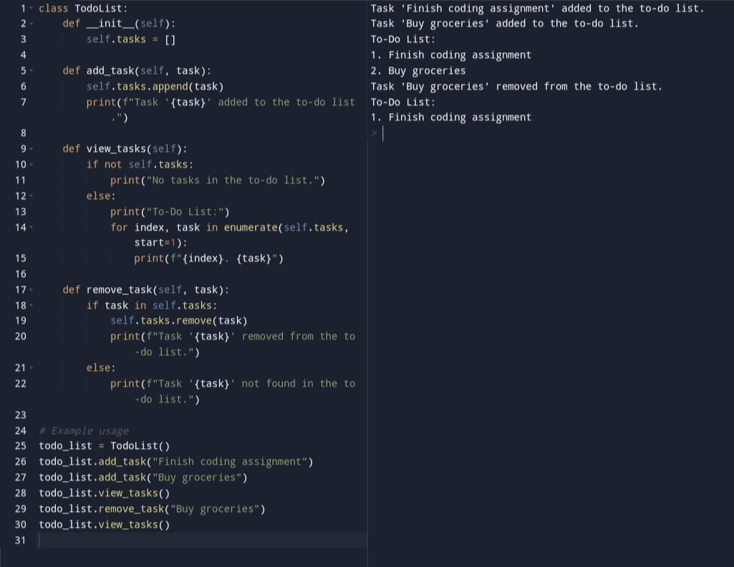

The End